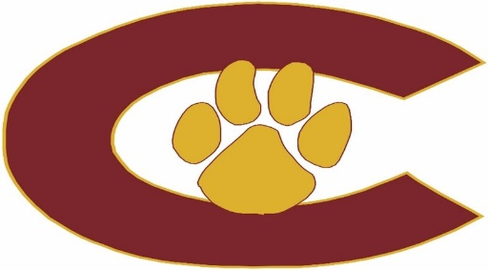

2025-26 BOWLING

DATE OPPONENT SITE H/A TIME JV/VAR
8/14 PreSeason Seminole Lanes n/a 3:30pm
8/28 Seminole Liberty Lanes A 3:30pm
9/4 Indian Rocks Liberty Lanes A 3:30pm
9/11 Gibbs Seminole Lanes H 3:30pm
9/18+ Dunedin Maple Lanes A 3:30pm
9/25+ East Lake Dunedin (?) A 3:30pm
10/2* St Petersburg Seminole Lanes H 3:30pm
10/9 Osceola Dunedin (?) A 3:30pm
10/16 PCACs TBD n/a TBD

10/20-23 District Tournament TBD TBD
10/28-30 State Tournament TBD TBD

TBD Banquet

*Senior Night
+District 1A D9 (Bell Creek, Brooks DeBartolo, Cambridge Christian, Cside, Dunedin, East Lake, Jesuit, Largo, PHU, SLAM, Tampa Prep, and Zephyrhills Christian)

Head Coach: Dion Patterson – pattersondi@pcsb.org
Asst Coach: Chris Crawford – crawfordchris@pcsb.org
Principal: Taylor Henderson – hendersont@pcsb.org
Athletic Director: Erin Overall – overalle@pcsb.org
Athletic Coordinator: Tony Klemmer – klemmera@pcsb.org
Athletic Trainer: Tillery Greco – tillery.greco@baycare.org
Assistant Principals: Brad Bernstein and Robert Murphy

Last update: 7/16/2025

